UNIVERSITY OF IBADAN
DEPARTMENT OF COMPUTER SCIENCE
1ST SEMESTER 2021/2022 EXAM
CSC 574: INTELLIGENT SYSTEMS
ATTEMPT QUESTION 1 & ANY OTHER 2. TIME ALLOWED: 2 HOURS
Question 1
- The university of Ibadan fire service is taking its operations to the next level. With the new fire building and the procurement of multi-million-naira fire equipment and vehicle. The fire service has also secured a grant to develop a UI-F Robot – a project involving 3 main departments, among which is computer science. Your first task is to develop a prototype.
- Demonstrate the various components of the prototype that qualifies it as being intelligent? (4 marks)
- Using appropriate schematic representation, describe the components in a procedural manner. (4 marks)
- In an experiment involving bags of words: {‘1’, ‘2’, China, Body, Writing, Worn-and-dry, Sleeve, Right-curve, Hand, Elbow, Large, Work, Coat, Holmes, Wilson, Apparel, Tattoo, Male, Person, Hat, Arm} a certain bag contained 21 words supposedly unrelated and not necessarily in any order. The selection is random and drawing-out is without replacement. The game thus requires you to give an order by:
- Draw a network/semantic graph from the set of words. Please note that selection is in any other. Your connectors/lines should have phrase that establishes relationships among the words. (10 marks)
- Generate 5 distinct sentences from your graph that are visible (5 marks)
- Give your succinct opinion on the sentence “Will Robots (Intelligent) displace humans”? (5 marks)
Question 2
- How would you treat the following problems? Give ample justification for your choice.(6 marks)
s/n | Scenario | Classification | Regression
a | Let’s say you are working on stock market prediction, and you would like to predict the price of a particular stock tomorrow (measured in naira). You want to use a learning algorithm for this. Would you treat this as a classification or a regression problem?
b | Assume you are working on predicting the weather, and your weather app makes one of three predictions for each day's weather: Sunny, Cloudy or Rainy. You decide to apply a learning algorithm to predict tomorrow's weather. Would you treat this as a classification or a regression problem? Give ample justification for your choice.
- Determine which is the best approach for each problem with brief explanation. (9 marks)
- supervised learning, b.) unsupervised clustering, c.) data query
  - What is the average weekly salary of all female employees under forty years of age?
  - Develop a profile for credit card customers likely to carry an average monthly balance of more than $1000.00.
  - Determine the characteristics of a successful used car salesperson.
  - What attribute similarities group customers holding one or several insurance policies?
  - Do meaningful attribute relationships exist in a database containing information about credit card customers?
  - Do single men play more golf than married men?
  - Determine whether a credit card transaction is valid or fraudulent.

Question 3
Hope Multiventure is a large business enterprise that operates a range of businesses, including supermarkets, bakeries, hotels, hospitals, and logistics. The board of directors has decided to automate major units of their business ventures. They have purchased AI-assisted robots from the United Kingdom to assist with customer care, hotel, hospital, and supermarket operations.
(a) Mention and explain 5 benefits that Hope Multiventure will derive from the decision of the board of directors. (9 marks)
(b) Discuss two drawbacks from their action. (3 marks)
(c) Mention two tasks that AI robots in Hope Multiventure can perform better than human and another two tasks that humans can perform better than AI robots. (3 marks)

Question 4
George Dolphen is a renowned Home Care Facility establishment for providing health care for aged men and women. The customer unit of the company has over 15 staff that attends to calls from customers who wants to know about the Home as well as the welfare of their parents in the home. Due to the cost incurred in paying the staff, the manager decided to acquire an AI robot to perform the task so that the overhead cost can be reduced. The machine performs the task effectively and the major backbone of the robot is based on Natural Language Processing techniques in Artificial Intelligence.
(a) Discuss step by step all five out of six stages that are involved before the robot can respond to calls from customers accurately. (7 marks)
(b) Discuss these concepts from your understanding of AI robots acquired by Hope Multiventure from the above question.
(i) Artificial narrow intelligence (2 marks)
(ii) Artificial general intelligence (2 marks)
(iii) Artificial super intelligence. (2 marks)
(c) Discuss two major differences between Stemming and Lemmatization in NLP. (2 marks)

MARKING SCHEME
Question 1
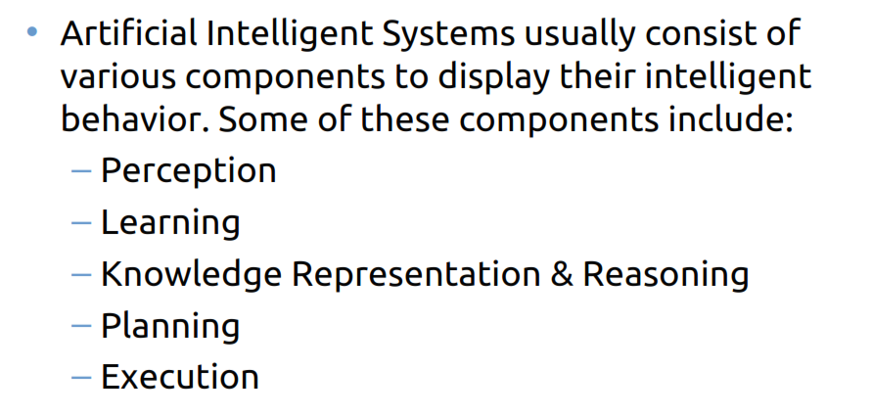
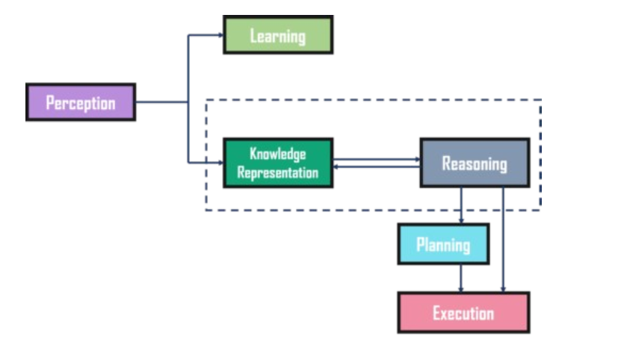

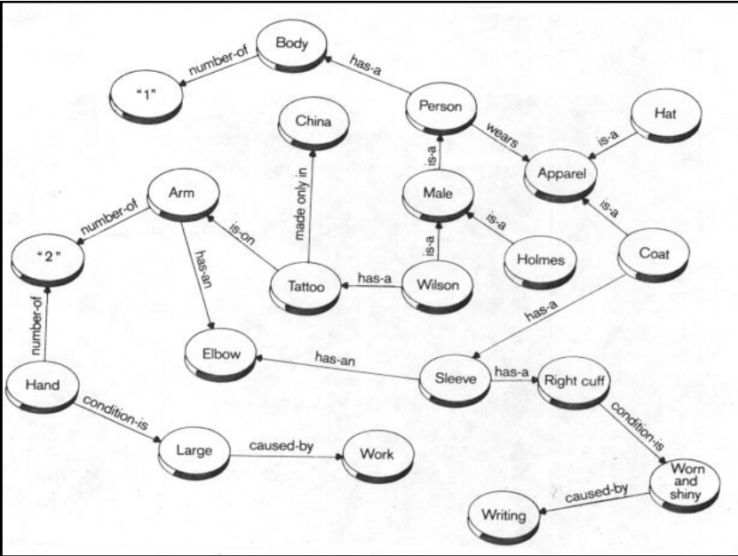

Question 2

Matching Questions
  - c
  - a
  - a
  - a
  - b
  - c
  - a

Question 3
(3a) AI robots have become increasingly popular in the business world due to their ability to streamline processes, reduce costs, and improve efficiency. Some of the advantages of AI robots in business ventures include:
1. Automation of routine tasks: AI robots can automate repetitive and mundane tasks, freeing up employees to focus on more complex and creative work.
2. Improved accuracy: AI robots can perform tasks with greater accuracy and consistency than humans, reducing the risk of errors and improving the quality of work.
3. Increased productivity: By automating tasks and improving accuracy, AI robots can help businesses increase productivity and output.
4. Cost savings: AI robots can help businesses save money by reducing labor costs and increasing efficiency.
5. 24/7 availability: Unlike human workers, AI robots can work around the clock without the need for breaks or rest, ensuring that tasks are completed quickly and efficiently.
(3b)
However, it is important to note that there are also some potential drawbacks to using AI robots in business ventures, such as the high cost of implementation and the potential for job displacement.
(3c)
Computers are better than humans at performing tasks that require repetitive actions, parallel processing, and data manipulation. . They can also perform tasks that require a high degree of precision, such as manufacturing and assembly line work .
However, there are still many tasks that computers cannot perform as well as humans, such as communication, creativity, and empathy

Question 4
(4a): Segmentation, Tokenization, Stop words, Stemming, Lemmatization, Speech Tagging
(4b)
1. Artificial narrow intelligence (ANI): ANI, also referred to as weak AI or narrow AI, is application- or task-specific AI. It is programmed to perform singular tasks such as facial recognition, speech recognition in voice assistants in hotel for Hope Multiventure, or driving a car for logistic units. They simulate human behavior based on a limited set of parameters, constraints, and contexts.
2. Artificial general intelligence (AGI): AGI, also referred to as strong AI or deep AI, is the ability of machines to think, comprehend, learn, and apply their intelligence to solve complex problems, much like humans. Strong AI uses a theory of mind AI framework to recognize other intelligent systems’ emotions, beliefs, and thought processes. A theory of mind-level AI refers to teaching machines to truly understand all human aspects, rather than only replicating or simulating the human mind. They can work in hospital in the Hope Multiventure.
3. Artificial superintelligence (ASI): ASI, also referred to as super AI, is AI that surpasses human intelligence. It is capable of performing tasks that are beyond human capabilities and can learn and improve itself at an exponential rate. Hope Multiventure can use it in their hospital for complex surgery after series of training.
(4c)
Stemming and lemmatization are two common techniques used in Natural Language Processing (NLP) to reduce words to their base or root form. The goal of both techniques is to reduce inflectional forms and sometimes derivationally related forms of a word to a common base form. However, the two techniques differ in their approach and accuracy .
Stemming is a heuristic process that chops off the ends of words in the hope of achieving this goal correctly most of the time. It often includes the removal of derivational affixes. Stemming is faster and simpler than lemmatization but can be less accurate.
Lemmatization, on the other hand, is a more accurate technique that uses a vocabulary and morphological analysis of words to remove inflectional endings only and to return the base or dictionary form of a word, which is known as the lemma. Lemmatization is context-dependent and considers the part of speech of the word. It is a canonical dictionary-based approach and has higher accuracy than stemming.
In summary, stemming is a rule-based approach that is faster and simpler than lemmatization but can be less accurate. Lemmatization is a more accurate technique that is context-dependent and uses a vocabulary and morphological analysis of words to return the base or dictionary form of a word.

